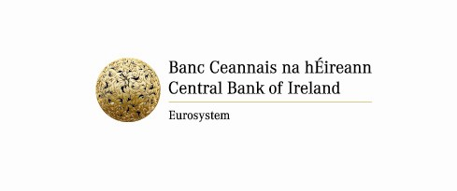
Compliance Form
Details | Response
- Fund/Sub-Fund(s) affected by error/breach.
- Description of error/breach, including details of error/breach and parties responsible.
- Impact of error/breach on NAV (% of NAV).
- Duration of error/breach (time period), including date the issue occurred, date it was detected and date it was rectified.
- Total number of shareholders/unit holders affected, including details of subscriptions/redemptions impacted by error/breach.
- Is Compensation required? | Yes or No
6a. Amount of compensation paid to shareholders/unit holders who have redeemed.
Who pays for the compensation?
Has the compensation been paid?
6b. Amount of compensation paid to shareholders/unit holders in the form of additional shares/units.
Who pays for the compensation?
Has the compensation been paid?
6c. Amount of compensation paid into the Fund/Sub-Fund(s).
Who pays for the compensation?
Has the compensation been paid?
Total Amount of Compensation = 6a + 6b + 6c
- Provide a copy of the calculation of compensation.
- Provide a copy of depositary’s written review/assessment/feedback of/on compensation. Also, provide a copy of any depositary report(s) on error/breach.
- If not rectified, detail the actions that are planned to rectify the error/breach, including details on the expected timeframe to complete these actions.
- Provide a copy of any incident reports or other supporting documentation.
- What internal investigation took place and what measures/controls are being put in place to prevent similar incident?
Are there any misconduct/disciplinary issues concerning the responsible entity and staff?
Set out the actions taken or to be taken to deal with or improve internal controls.
- Have/are any other regulatory bodies being notified of this matter?
If yes, please provide details.
- Are there any other issues related to this matter that you wish to bring to the attention of the Central Bank of Ireland?
- Has the Depositary received written confirmation from the Board of Directors/Fund Management Company that this matter has been fully rectified and that all investors have been treated fairly? | Yes or No
- Is the Depositary satisfied that this matter has been fully rectified and that all investors have been treated fairly? | Yes or No
- Is any sub-fund impacted by this matter a “UCITS Master Fund” or a “UCITS Feeder Fund”?
If yes, please provide details.
- Are any of the sub-funds impacted by this error/breach distributed on a cross border basis to non-qualified (retail) investors in Switzerland?
If yes, please indicate the name of the sub-fund(s) affected.
- Have you or are you reporting this matter to any other Competent Authority? Please identify all such Competent Authorities. Please provide date of reporting/planned reporting.
- Name, Telephone Number and Email Address of contact with whom the Central Bank of Ireland can engage with in respect of this report.

If any field is Not Applicable (“N/A”) please mark as such - Do not leave blank

