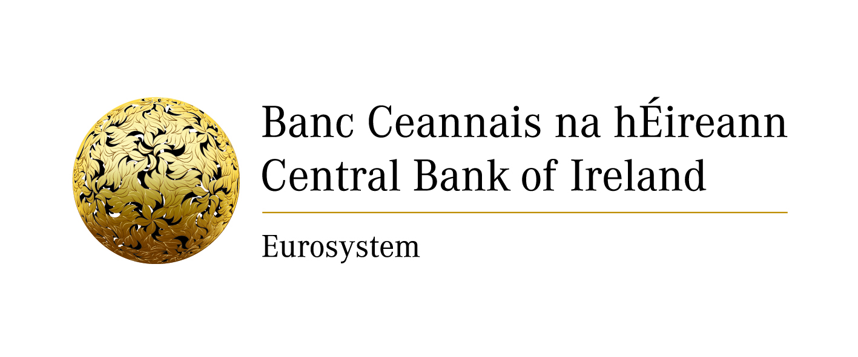
Notification form for exercising the freedom of establishment

NOTE: The Central Bank may process personal data provided by you in order to fulfil its statutory functions or to facilitate its business operations. Any personal data will be processed in accordance with the requirements of data protection legislation. Any queries concerning the processing of personal data by the Central Bank may be directed to dataprotection@centralbank.ie. A copy of the Central Bank’s Data Protection Notice is available at www.centralbank.ie/fns/privacy-statement.

1 | Host Member State
2 | Type of notification | First notification  Change to previous notification
3 | Name of mortgage credit intermediary
4 | Date of birth in case of natural person | DD/MM/YYYYY
5 | Home State registration number
6 | Head office address
7 | Email
8 | Telephone number
9 | Fax number
10 | Name of home competent authority | Central Bank of Ireland
11 | Home Member State | Ireland
12 | Web address of the online register | www.centralbank.ie
13 | Branch details  • Address  • Telephone number  • Email  • Fax number
14 | Name(s) and date(s) of birth of natural person(s) responsible for the management of the branch
15 | Services to be provided by the mortgage credit intermediary in the host Member State | offers/presents credit agreements  assists in preparatory/pre-contractual administration work  concludes credit agreements  provides advisory services
16 | Tied mortgage credit intermediary | Yes  No
17 | In the case of a tied mortgage credit intermediary:  a) Name and registration number of the creditor or group to which the intermediary is tied in the host Member State  b) Whether the mortgage credit intermediary is exclusively tied to only one creditor  c) Confirmation that the creditor takes full and unconditional responsibility for the mortgage credit intermediation activities | - ..………………………………..  - …………………………………  - ………………………………....

